

DRAFT
Technical Design

Melbourne IT OFC
MIT GL Journal Lines Report

Author: Tony Whelan
Creation Date: 7 April 2017
Last Updated: 11 April 2017
Version: 1.0
Table of Contents

1. Requirement 3
2. Solution Overview 3
3. Technical Objects 4
3.1 BI Publisher XML Data Definition File 4
3.2 BI Publisher RTF Report Template 4
4. Configuration 4
4.1 Define Value Sets 4
4.2 Define Concurrent Program 6
4.3 Define XML Data Definition 7
4.4 Define XML Template 7
4.5 Update Request Group 8
5. Report Execution 9

Requirement

Melbourne IT Finance has a requirement for a General Ledger Journal Lines Report that reports Journal Lines data across all Oracle EBS OFC Ledgers to assist with the Month End Close process

The Data columns include:
Posting Status
Reversal Flag
Reversal Status
Manual or System Journal
Period Name
Ledger Name
Legal Entity
Cost Centre
Business Entity
Natural Account
Balancing Segment
Account Description
Journal Header ID
Journal Name
Journal Source
Journal Category
Currency Code
JE Line Number
Line Description
Effective Date
Date Created
User Name
Entered Dr
Entered Cr
Accounted Dr
Accounted Cr

The Parameters include:
Ledger
Period Name
Reversal Flag

Solution Overview

MIT GL Journal Lines Report has been developed and configured using the Oracle EBS XML BI Publisher. This document describes the configuration and execution of XML Report MIT GL Journal Lines Report to provide the above information.

Technical Objects

BI Publisher XML Data Definition File
This file contains the SQL query, data elements and parameters for the report.
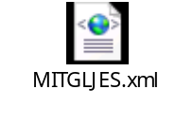

BI Publisher RTF Report Template
This file contains the xml markup and report layout definition for the report.


Configuration

Define Value Sets
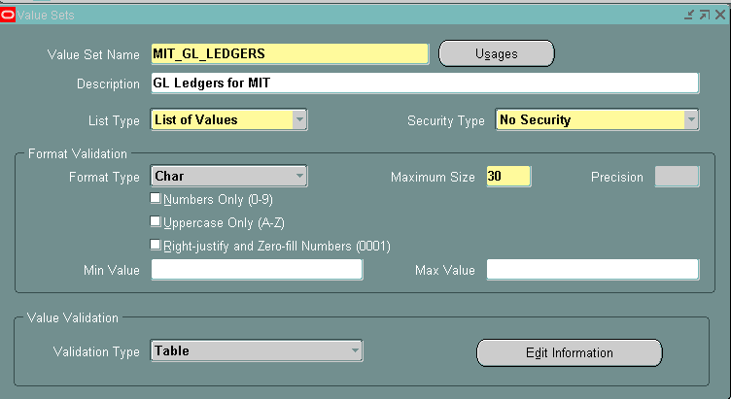

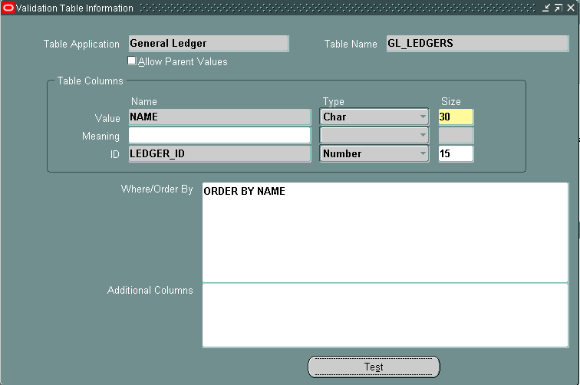

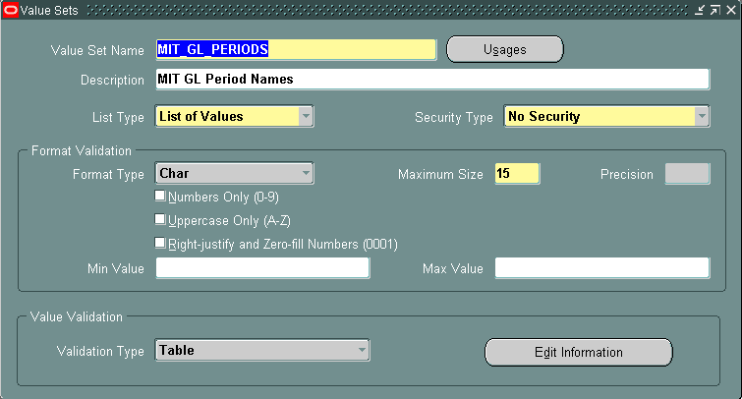

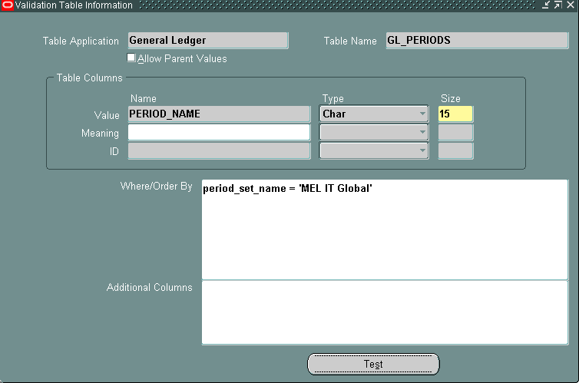

Define Concurrent Program
Responsibility: System Administrator
Menu Path: Concurrent -> Program -> Define
Form: Concurrent Program
Purpose: Define a new concurrent program.

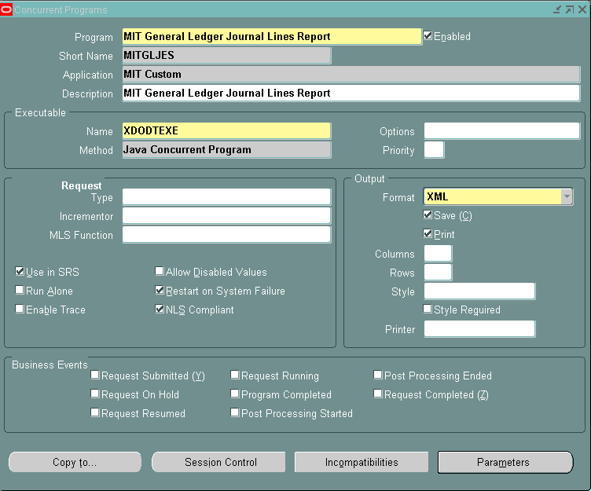

Parameters:
Seq. | Parameter | Value Set | Disp. Size | Prompt | Token
10 | Ledger | MIT_GL_LEDGERS | 30 | Ledger | P_LEDGER
20 | Period | MIT_GL_PERIODS | 15 | Period Name | P_PERIOD_NAME
30 | Auto Reversal Journals Only | GL_SRS_YES_NO_MAND | 50 | Auto Reverse Only | P_AUTOREVERSE_FLAG

Define XML Data Definition
Responsibility: XML Publisher
Menu Path: Home -> Data Definitions
Form: Data Definition
Purpose: Define the Data Definition in XML Publisher; attach the XML Data Definition file.

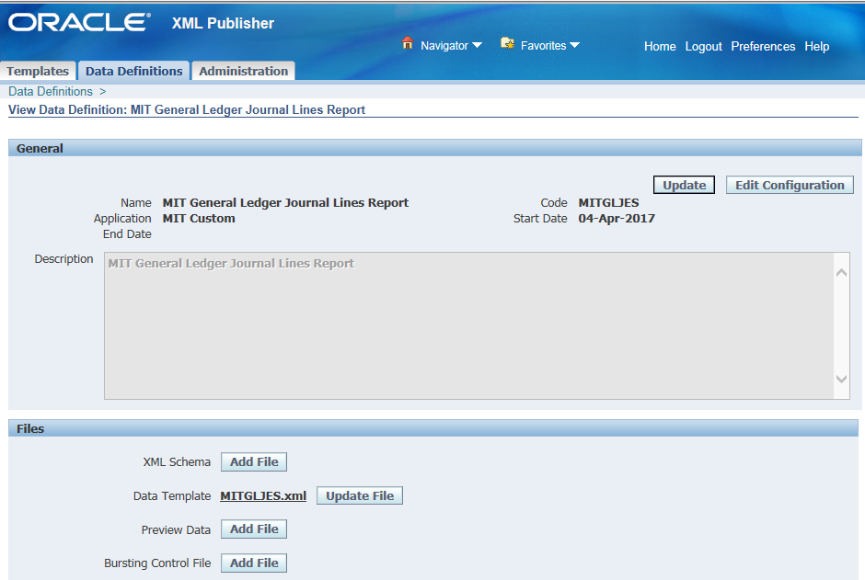

Define XML Template
Responsibility: XML Publisher
Menu Path: Home -> Templates
Form: Templates
Purpose: Define the Layout Template; attach the RTF Report Template file.

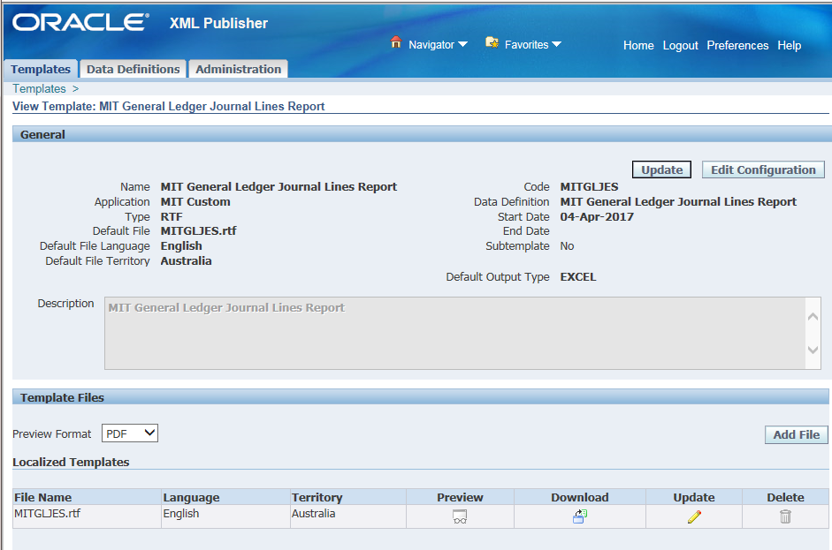

Update Request Group
Responsibility: System Administration
Menu Path: Security-> Responsibility -> Define
Form: Request Group
Purpose: Add the Report to the General Ledger Request Group
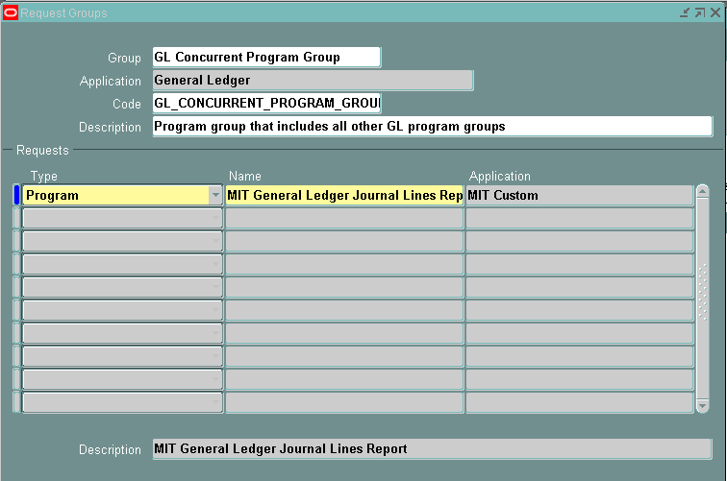

Report Execution

- Login to your OFC General Ledger Responsibility and execute the Concurrent Requests program.
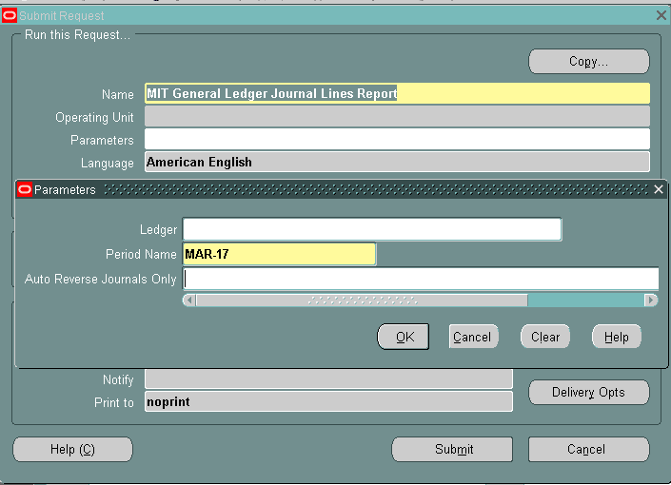

- Enter or select MIT General Ledger Journal Lines Report.
- Enter or select the required Parameters for the report data:-
  - Ledger
  - Period Name
  - Auto Reverse Journals Only
- Submit the Report.
- Execute the View -> Requests menu.
- Click the View Output button in OFC Requests form
- Click the Open or Save option in the Internet Explorer window. This will save the report in your standard Downloads folder.

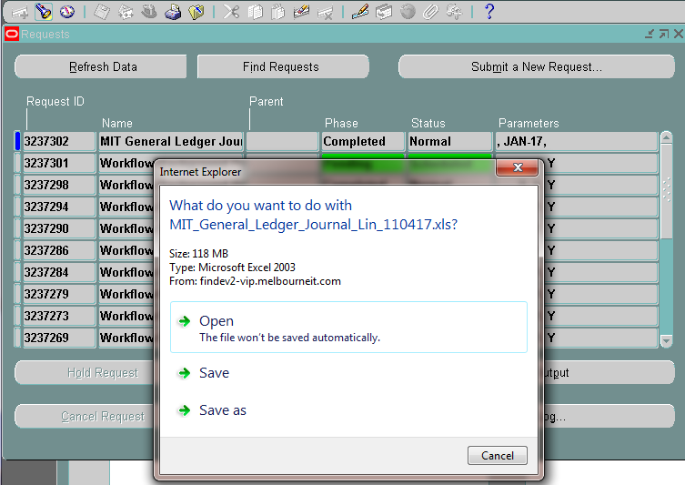

- Navigate to your Downloads folder and open the report file.

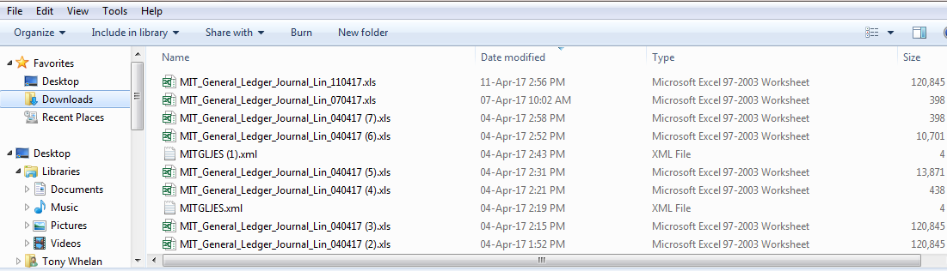

- Click ‘Yes’ to ignore the file format extension warning due to different versions of Excel.
- The report output will be displayed in Excel format.

